Rocket Trajectory Visualisation Tool

How to use Guide

A comprehensive visual guide on how to use the tool and its features from the perspective of a user. Does not go over setup, adding data, or modifying features.

Contents

Starting the Tool 3

Running the tool using Unity Editor 3

Running the tool from a standalone build 3

Controls 4

Using the Graph Creator Interface 4

Interface Elements 4

Graph Spawn Circles 5

Spawning a Graph 5

Graphs – Scatter 6

Scatter Elements 6

Scatter Interfaces 6

Animation UI 6

Config Menu 7

Filtering Menu 8

Data Display 8

Pop-up Display 9

Legend 9

Graphs – Bar 10

Bar Elements 10

Bar Interfaces 10

Config Menu 10

Highlighting Menu 11

Attaching Bar Graph to Scatter Graph 12

Scatter Graph Config 12

High-Level Bar Graph 12

Moving Objects 13

Moveable Blocks 13

Pop-up Displays 13

# Starting the Tool

## Running the tool using Unity Editor

After making sure that the project has been downloaded and opened with unity, do the following to run the tool:

1. Make sure the project is using the ‘Main’ scene. This can be found in the Assets/Swordfish folder.
2. Double click on the ‘Main’ file to launch the scene.
3. Click the play button the run the project. Make sure that your VR gear is connected to your computer before this step, and that its running Steam VR/ Oculus VR/ another support VR runtime with unknown/ external app running enabled.

## Running the tool from a standalone build

(To be written. The tool has yet to be compiled into a standalone application).

# Controls

The controls for the tool is universal, provided the VR controllers have standardised inputs. They are as follows:

|  |  |
| --- | --- |
| **Trigger button** | Selecting datapoints  Selecting bars in the bar chart  Grabbing move blocks/ data windows  Selecting UI elements *(while pointer is active)* |
| **Primary Button (A/X button)** | Select datapoints trajectory for the animation playback |
| **Left Thumbstick/ Touchpad** | Movement |
| **Right Thumbstick/ Touchpad** | Rotation |
| **Left Grip Button** | Toggle creator menu visibility |
| **Right Grip Button** | Activate pointer |

# Using the Graph Creator Interface

The graph creator interface can be found attached to the left controller in the VR space. Using the interactive pointer, you can select the interface elements to customize and generate a graph.

## Interface Elements

|  |  |
| --- | --- |
| 1. **Input Conditions** – options for the input conditions to use, via its folder. 2. **Axis** – X, Y, and Z axis selection. All output variables within dataset is available to use. 3. **Graph Dimension** – 2D or 3D graph selections. This will limit axis selection. 4. **Graph Type** – The type of graph to create. This will limit axis and graph dim. options. 5. **Hide** – Hides the creator menu. This can also be done with left grip (see controls). 6. **Audio** – Toggles all audio in the scene. 7. **Create Graph** – Takes all the given options and generates a graph from them. |  |

## Graph Spawn Circles

In the scene, there are circles on the floor to help show where graphs can/ will spawn. These circles are interactive and can be selected by the user’s interaction pointer to choose a spot to spawn a graph, otherwise they will be chosen automatically.

If a user chooses a circle that’s in use, a new graph will replace the existing graph there. If all spots are filled and no new spots are selected by the user, graphs will not spawn anymore.

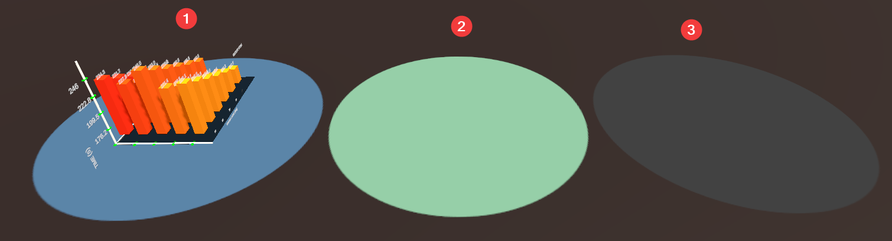

1. **Blue Circle** – Spawn spot that is currently in use. Can be overwritten with a new graph if selected by the user, otherwise will not automatically be selected.
2. **Green Circle** – Next/ selected spawn spot. This indicates the next spot a graph will spawn.
3. **Grey Circle** – Unused/ unselected spawn spot. These spots will automatically be used as graphs are added, with the closest counter-clockwise spot from the first spot being selected.

## Spawning a Graph

After the graph creator fields has been filled out, and a spawn circle is selected, the user can click the ‘Create Graph’ option. If there is a selected spawn circle in the scene, the graph will start to generate there, along with a progress bar showing the percentage of the graph that has been made:



Once the graph has finished generated, it will be fully interactable.

# Graphs – Scatter

## Scatter Elements

The scatter graph has several unique elements that make it up:

|  |  |
| --- | --- |
| **Rocket** – Used for the animation playback and showing the elapsed time on the selected graph trajectories. |  |
| **Datapoint** – One of many points in a trajectory, represents a single point in time, containing all the variables for that time step. Can be selected to display these variables. |  |
| **Trajectory Line** – Each set of points sit along these lines, which represent the path of the rocket and how the datapoints connect. |  |
| **Axes and labels** – Each axis has a set of ticks and labels, showing which variable the axis represents, and the values of each tick. |  |
| **Longitude and Latitude** – Above each graph is the longitude and latitude where each rocket launch/ simulation took place. |  |

## Scatter Interfaces

### Animation UI

The animation UI allows a single trajectory to be chosen and have a rocket be animated through its datapoints. The rocket is animated based on time, and

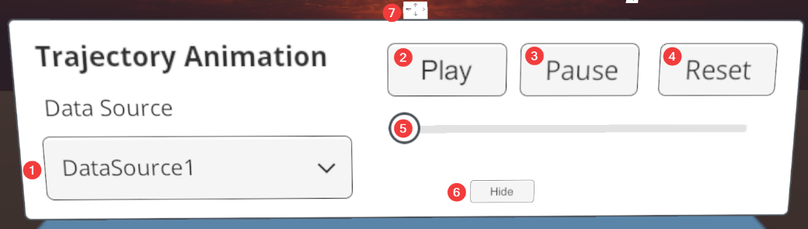

1. **Data Source** – A dropdown allowing the user to choose a single trajectory to animate.
2. **Play** – Plays the animation from the current point the rocket/ slider is at.
3. **Pause** – Stops the animation at its current point.
4. **Reset** – Moves the rocket/ slider to the first point.
5. **Slider** – Shows and allows selecting of the elapsed rocket flight time.
6. **Hide** – Minimises the menu to a small button, which can be used to bring the window back.
7. **Mover** – Allows the user to move the menu. See controls for usage.

### Config Menu

The graph graph configuration menu allows the user to shift through the trajectories and their values, as well as change the axes, input folders, and visible variables of the graph.

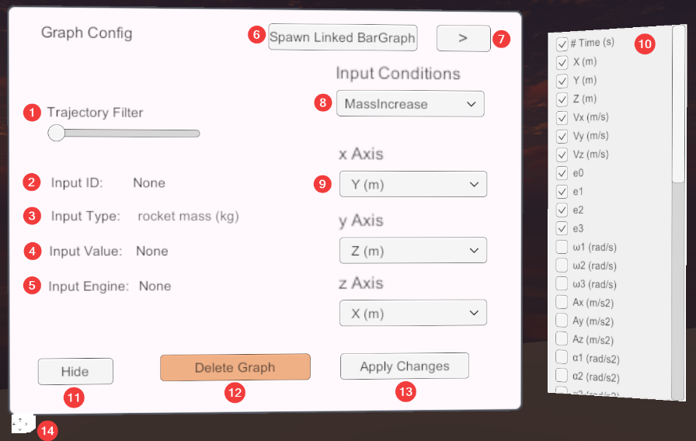

1. **Trajectory Filter** – Selects a single trajectory, hiding all the others. At min value, all are shown.
2. **Input ID** – The ID of the chosen trajectory
3. **Input Type** – The input variable that is the focus of the dataset (the changed inputs)
4. **Input Value** – The value of input type that was set for the chosen trajectory.
5. **Input Engine** – The engine that was used for the selected trajectory
6. **Spawn Linked BarGraph** – Spawns a high-level bar graph using the Third Level Chart Linking Manager. Clicking it while it is spawned will remove it. Further details in its dedicated section.
7. **Variable Window** – Toggles the output variable visibility window. Further details in (10).
8. **Input Conditions** – Options for which input conditions to use, which are the dataset folders.
9. **Axis** – X, Y, and Z axis selection. All output variables within dataset is available to use.
10. **Variable Toggles** – All the output variables shown in the data display and popup windows. Use the toggles to show or hide variables in these windows. These toggles will update straight away and don’t need to be applied.
11. **Hide** – Minimises the menu to a small button, which can be used to bring the window back.
12. **Delete Graph** – Removes the graph from the scene. A confirmation appears before deletion.
13. **Apply Changes** – Applies all the changed fields in the config, updating the graph.
14. **Mover** – Allows the user to move the menu. See controls for usage.

### Filtering Menu

The filtering menu allows the user to filter out variables that don’t match the given specifications, such as removing trajectories with less than 200 seconds for flight time.

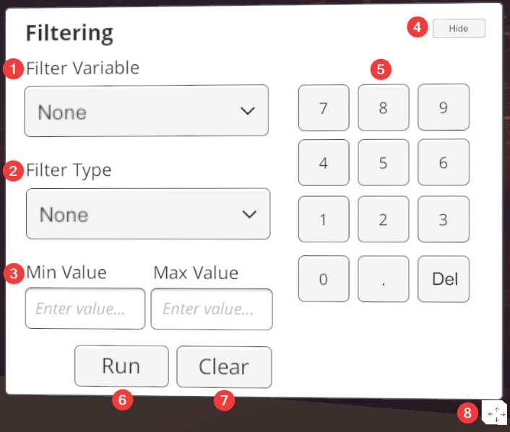

1. **Filter Variable** – The variable to use for the filter (time, y distance, etc.).
2. **Filter Type** – The filtering condition for the variable (more than, between, etc.).
3. **Values** – The values to be used for the filtering condition. Changes based on filter type.
4. **Hide** – Minimises the menu to a small button, which can be used to bring the window back.
5. **Keypad** – Interactive keypad too type into the value fields.
6. **Run** – Applies the filter to the graph.
7. **Clear** – Removes the filter from the graph, resetting the menu fields.
8. **Mover** – Allows the user to move the menu. See controls for usage.

### Data Display

The data display window will show the unhidden variables of a single trajectories point, based on the time elapsed in the animation UI. This window will update with the animation, and have its contents updated when the variable visibility toggles are changed.

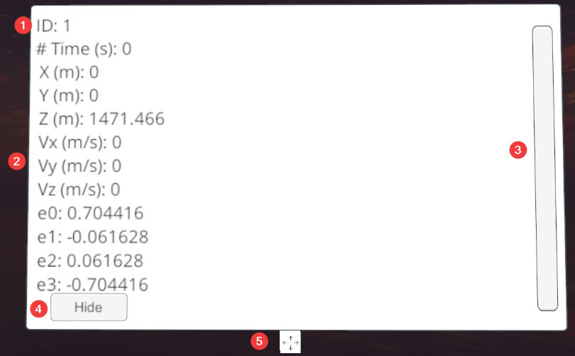

1. **ID** – The ID of the selected data source, chosen from the animation UI or config filter.
2. **Output Variables** – The variables and their current value for the current data point.
3. **Scrollbar** – Used to scroll through larger lists of variables.
4. **Hide** – Minimises the menu to a small button, which can be used to bring the window back.
5. **Mover** – Allows the user to move the menu. See controls for usage.

### Pop-up Display

When a datapoint is selected by the user (see controls), a pop-up display containing the information on a point will appear. This window shows the same data as the data display, but multiple can be selected at the same time.

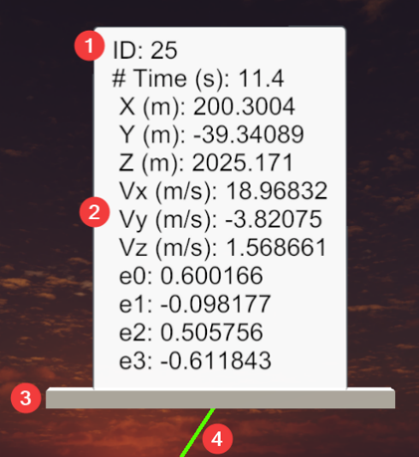

1. **ID** – The ID of the selected datapoints trajectory/ data source.
2. **Output Variables** – The variables and their value for the datapoint.
3. **Mover** – Allows the user to move the menu. See controls for usage.
4. **Connector** – a visual link between the pop-up window and the datapoint it belongs to.

### Legend

The legend displays the meanings behind each colour for the datapoints, depicting the different stages of the rockets flight.

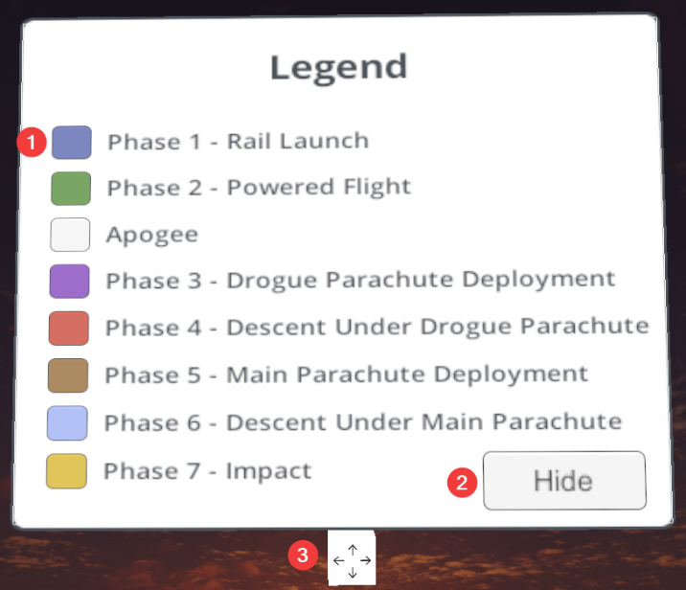

1. **Contents** – The colour and description of each of the different rocket phases.
2. **Hide** – Minimises the menu to a small button, which can be used to bring the window back.
3. **Mover** – Allows the user to move the menu. See controls for usage.

# Graphs – Bar

## Bar Elements

The bar graph is made up of several different elements, including:

|  |  |
| --- | --- |
| **Axes and Labels** – Each axis on the bar graph represents a different input variable, with Y and Z being time and motor type by default, and X being the other input variable that is being changed and focussed on.  Each axis has labelled ticks representing variable values, and labels for the variable on that axis. |  |
| **Bars** – The data in the graph is represented by bars, which can be clicked on to open a pop-up data window for that bar. When using the highlighter menu, there bars will turn green when they are highlighted. |  |
| **Bar Values** – The value on each bar depicts their maximum Y values, or in this case time. When using the highlight menu, these values will only appear on the bars that are selected. |  |

## Bar Interfaces

### Config Menu

The config menu for the bar graph allows the user to configure the dataset and displays for the graph.

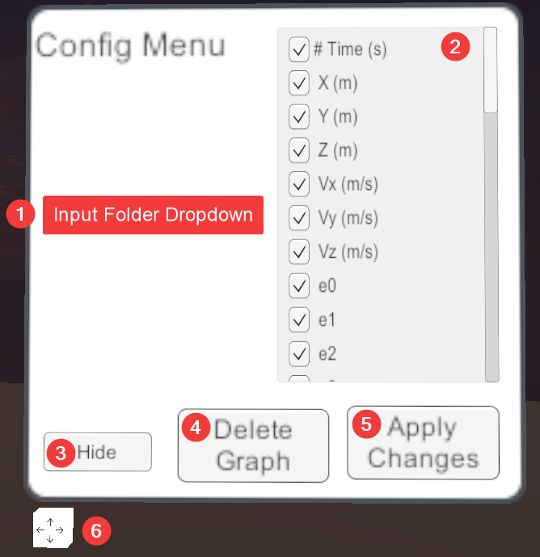

1. **Input Conditions** – Options for which input conditions to use, which are the dataset folders.
2. **Visibility Toggles** – All the output variables shown in the popup windows. Use the toggles to show or hide variables in these windows. These toggles will update straight away and don’t need to be applied.
3. **Hide** – Minimises the menu to a small button, which can be used to bring the window back.
4. **Delete Graph** – Removes the graph from the scene. A confirmation appears before deletion.
5. **Apply Changes** – Applies all the changed fields in the config, updating the graph.
6. **Mover** – Allows the user to move the menu. See controls for usage.

### Highlighting Menu

The highlighting menu allows the user to highlight a row and column of the bar graph, focusing on those variables. This menu provides more functionality when the bar graph is attached to the scatter graph. See the section on this for further details.

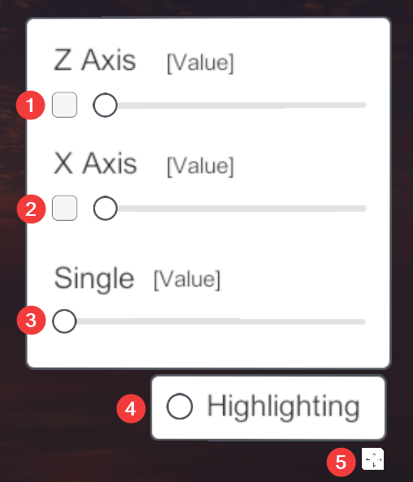

1. **Z Axis Toggle/ Slider** – Allows toggling of highlighting and selection for the z axis.
2. **X Axis Toggle/ Slider** – Allows toggling of highlighting and selection for the x axis.
3. **Single Slider** – When both axes are toggled off, single allows you to highlight individual bars.
4. **Highlighting Toggle** – Toggles the highlighting functionality and menu.
5. **Mover** – Allows the user to move the menu. See controls for usage.

# Attaching Bar Graph to Scatter Graph

## Scatter Graph Config

## High-Level Bar Graph

# Moving Objects

## Moveable Blocks

## Pop-up Displays